Friday, August 26th CS 1025 class #3 Fall 2016
NetLOGO turtle graphics

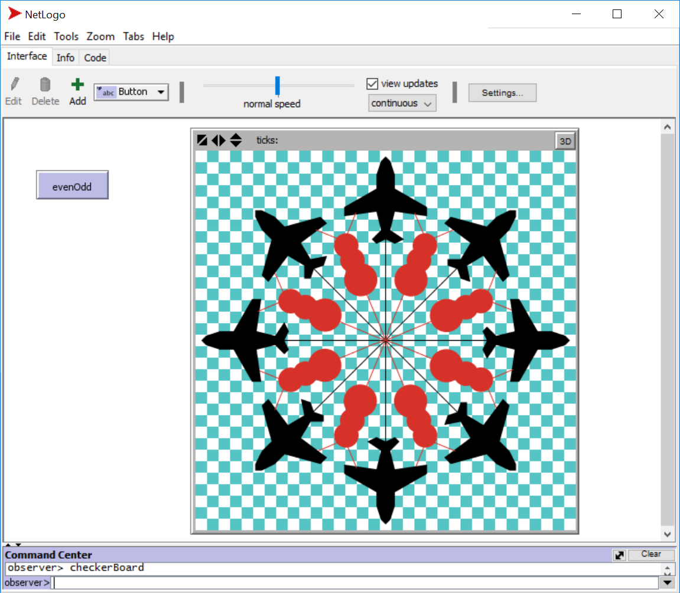

The example we started on Friday, August 26th, 2016 in CS 1025 class. To be continued during week #2. We did something like this is the 8 am and the 12 pm classes.
Questions will be answered and we will play with the code for this again on Monday, August 29th during class #4.
See the last page of this PDF for the code that you can copy and paste if you wish. We will start with this code by copying and pasting it into NetLOGO session on Monday.
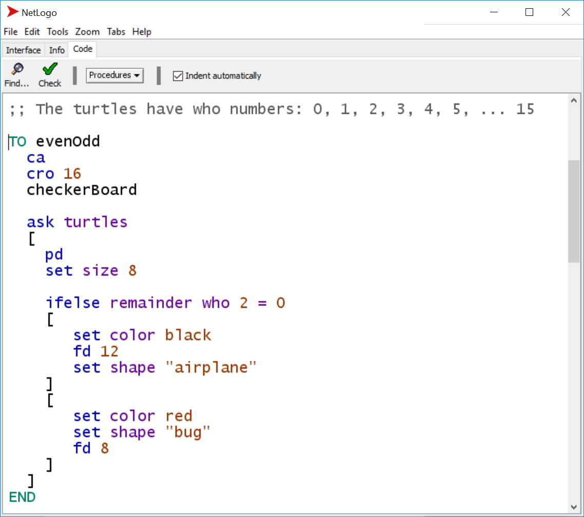

;; (pxcor + pycor) is either EVEN or ODD

TO checkerBoard ;; What is the REMAINDER when you divide
ask patches ;; by 2? It is either 0 or 1.
[
ifelse remainder (pxcor + pycor) 2 = 0
[
set pcolor white
]
[
set pcolor cyan
]
]
END
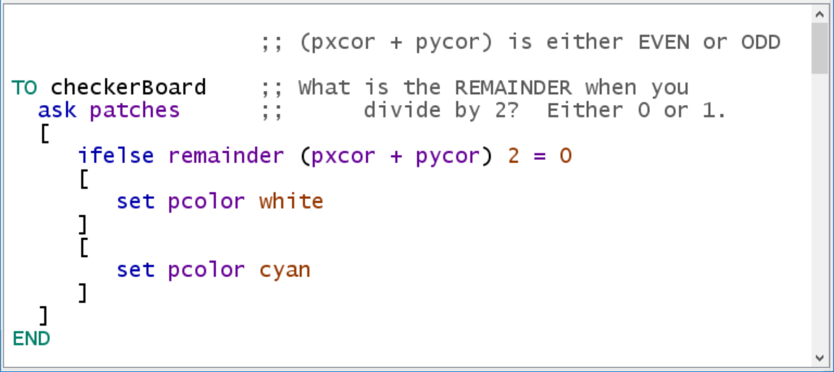
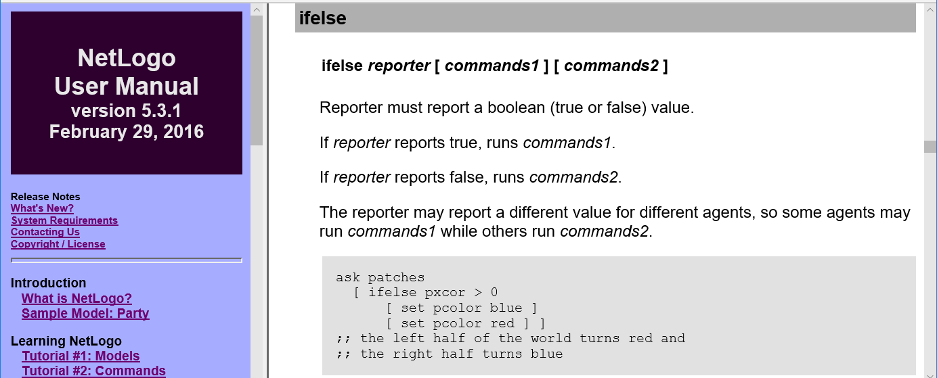

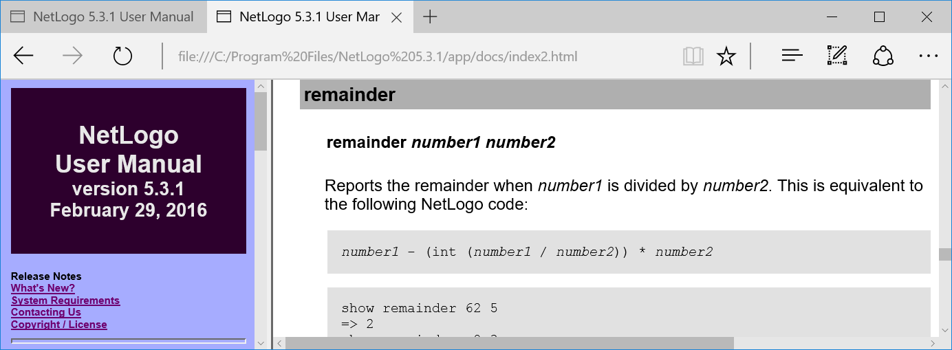
TO checkerBoard
ask patches
[
ifelse remainder (pxcor + pycor) 2 = 0
[
set pcolor white
]
[
set pcolor cyan
]
]
END

;; The turtles have who numbers: 0, 1, 2, 3, 4, 5, ... 15

TO evenOdd
ca
cro 16
checkerBoard

ask turtles
[
pd
set size 8

ifelse remainder who 2 = 0
[
set color black
fd 12
set shape "airplane"
]
[
set color red
set shape "bug"
fd 8
]
]
END

