- What are you given? What is given directly in the problem description and diagram on the board and in the NetLogo code? What is the desired result?

- What is the goal? Describe the goal in detail.

- What more do you need to know about the goal to make it more specific and help you achieve it? Are there some formulas you need to mobilize or recall or look up to achieve the goal and define it more precisely?

- Now draw a picture that is more detailed than the picture you or the instructor first drew on the board. Label any additional details you have found.

- Now switch to HOW to get from the given starting point to the goal or desired result?

- HOW do you draw a circle with NetLOGO? How do you draw an OCTAGON with NETLOGO?

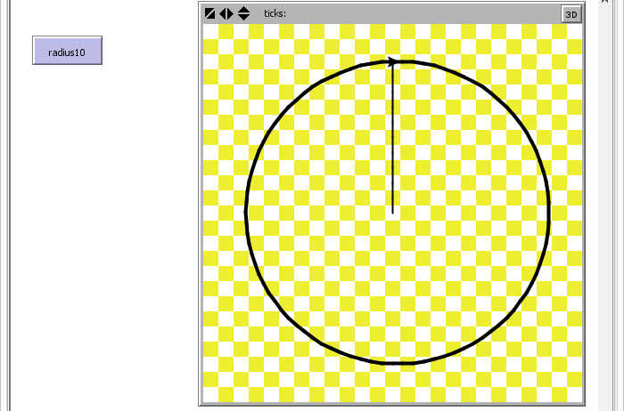
Write the drawCircle procedure in NetLOGO to successfully solve the problem shown and described above.
Resist the Urge to Code and follow the 3 step problem solving process taught in class. The above six questions are to guide you on the Understand WHAT the problem is phase and the Develop a PLAN of HOW to solve it phase. The 3rd and last phase is the CODE IT in NetLOGO phase. Resist the urge to Code IT too soon and spend time and effort in phase 1 and phase 2. Phase #1 is Dr Peter Venkman, phase #2 is Dr Raymond Stantz, phase #3 is Dr Egon Spengler.

