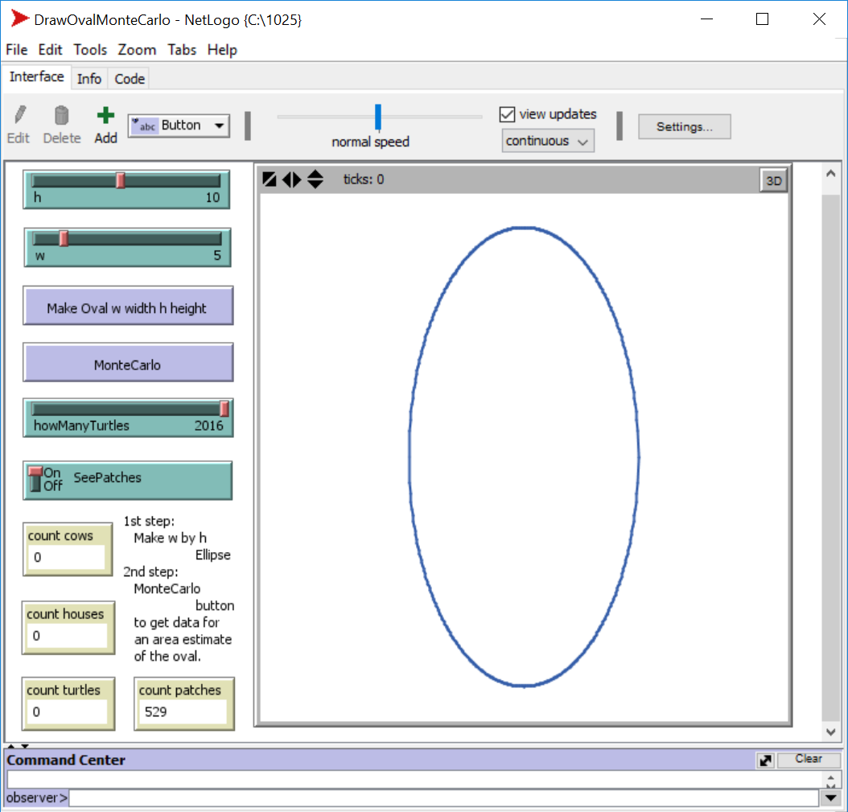
For the Wednesday 10/05/2016 class.
Monte Carlo practice.
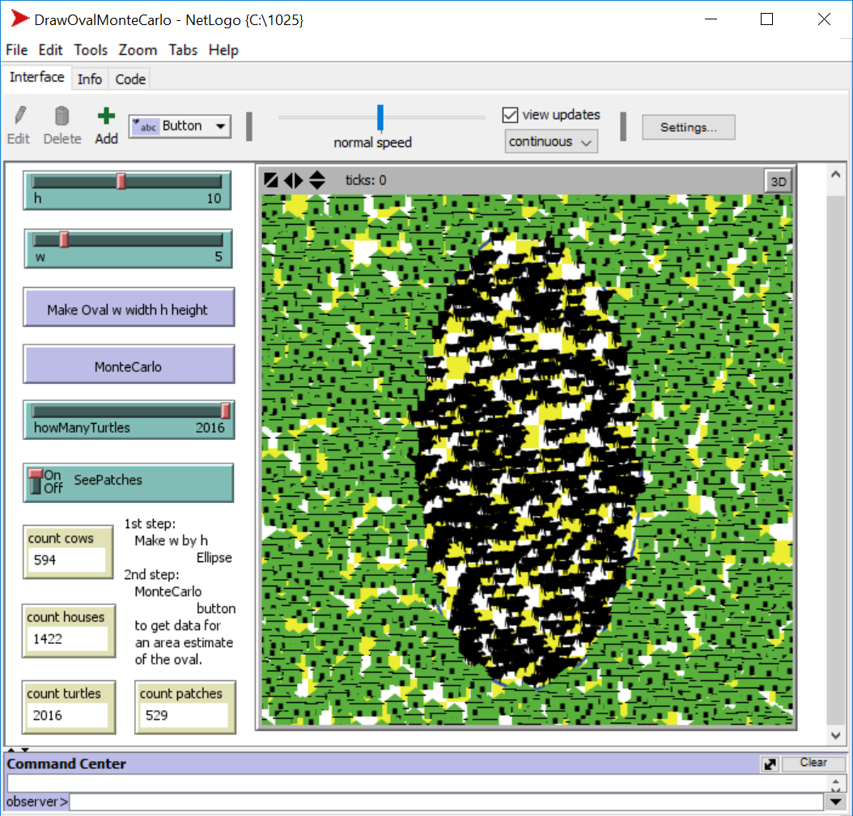
- What is a? Using the a = b/c times d formula from: MonteCarlo11_14_2012.pdf
- What is b?
- What is c?
- What is d?
- What is the estimated area of the OVAL, using the MONTE CARLO method and the counts?
This problem is for the Wednesday 10/05/2016 class. Solve it ahead of time on your own, or attempt to solve it.

