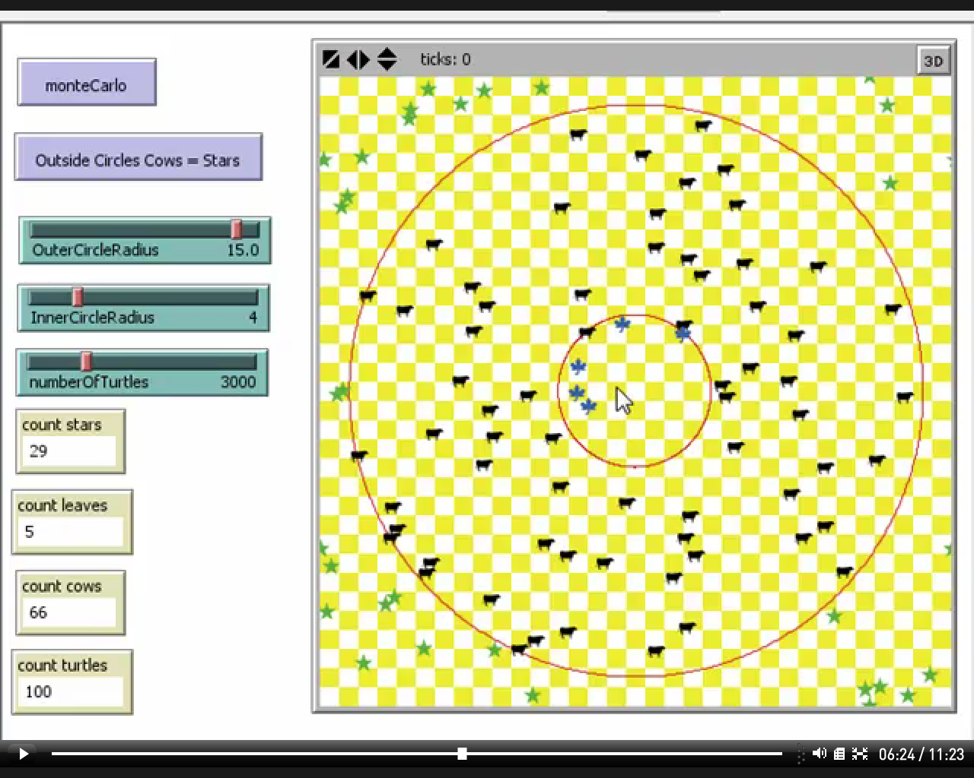
What is the estimated proportion of the entire area taken up by the inner circle?

What is the estimated proportion of the entire area taken up by the outer or larger circle?

What is the estimated proportion of the entire area that is outside the circles?

There are 33 rows and 33 column s of patches. 33 * 33 = 330 * 3 + 33 * 3 = 990 + 99 = 1089. Give the estimated area of the inner circle?

Give the estimated area of the outer circle?

Give the estimated area of the area outside both circles of trust.

