Chapter 3 Practice Problems
- Match each of the pairs of sets with the Venn diagrams provided
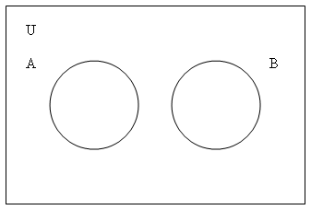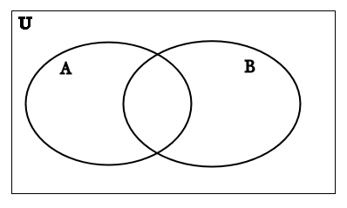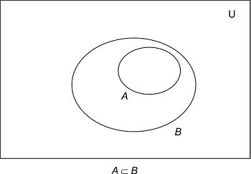

- A = {even numbers} , B = {odd numbers}
- A = {prime numbers} , B = {odd numbers}
- A = {numbers divisible by 4}, B = {even numbers}
- A = {students in this discrete class} , B = {students in data structures}
- A = { students in this discrete class }, B = {students in Networking}
- A = { students in this discrete class }, B = {students at UNI}

- Consider
T = {2,3,8,10}

What is the value of P(T)?

- Assume
- A = { letters in the word ELEPHANT }
- B = { letters in the word SYNCHOPHANT }
- C = {letters in the word FANTASTIC}
- D = {letters in the word STUDENT}
If the universe U is the set of 26 capital letters find:
- A ∪ B
- A ∩ B
- A ∩ C
- D ∪ A
- (A ∩ C ) ∪ (B ∩ D)
- A ∩ (C ∩ D)

- Write in words how to read each of the following out loud. Then write the shorthand notation for each set.
  - {x ∈ U | x ∈ A and x ∈ B }
  - {x ∈ U | x ∈ A or x ∈ B }
  - {x ∈ U | x ∈ A and x ∉ B }
  - {x ∈ U | x ∉ A}

- Let :
A = { 1,3,5,7,9}
B = { 3,6,9 }
U = {x ∈ Z | 0<x<10 }
Find the following
  - A ∪ B
  - A ∩ B
  - A ∪ U
  - A ∩ U
  - A – B
  - A^{c}
  - B^{c}

- Complete the following sentences without using the symbols ∩, ∪, and -.
  - x ∉ (A ∩ B) if, and only if, …
  - x ∉ (A ∪ B) if, and only if, …
  - x ∉ (A – B ) if, and only if, …

- Consider the following sets:
  - U = set of all students at UNI
  - S = set of all students with majors in CHAS
  - C = set of all computer science majors
  - P = set of all physics majors
  - F = set of all women students at UNI
What would the Venn diagram for these sets look like?

- Write an expression using the sets from activity #5 and the set operations to express the following:
  - The set of people majoring in either computer science or physics.
  - The set of people majoring in both computer science and physics.
  - The set of computer science majors who are women.
  - The set of people who do not have a major in CHAS.
  - The set of male students who are majoring in both computer science and physics.
  - The set of female physics students and male computer science students.

