Section 1.10 and 1.11
Part One
For each of the following pair of propositional statements, indicate whether you can conclude:
- p
- q
- ¬ p
- ¬ q
- No conclusion can be made
- There is an error in the pair of propositional statements
 | Suppose that you know this and … | this | What new thing can you conclude?
1 | p ∧ q | p
2 | p ∨ q | p
3 | p → q | p
4 | p ∧ q | ¬ p
5 | p ∨ q | ¬ p
6 | p → q | ¬ p
7 | p → q | q
8 | p → q | ¬ q

Part Two
For each exercise, decide what conclusion, if any, can be reached from the given hypotheses. Defend WHY.
- If the car was involved in the hit-and-run, then the paint would be chipped. But the paint is not chipped.

- Either the weather will turn bad or we will leave on time. If the weather turns bad, then the flight will be cancelled.

- If the bill was sent today, then you will be paid tomorrow. You will be paid tomorrow.

- The grass needs mowing and the trees need trimming. If the grass needs mowing then we need to rake the leaves.

Part Three
Use a truth table to show that hypothetical syllogism is valid.
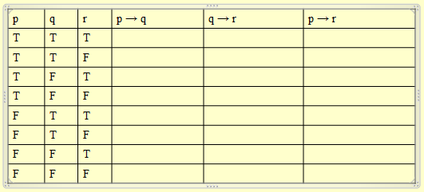
Part Four
Justify each step in the following proof sequences:
- Prove A ∧ ( B → C) → ( B → ( A ∧ C) )
  - A
  - B → C
  - B
  - C
  - A ∧ C

- Prove B ∧ [( B ∧C) → ¬ A ] ∧ ( B → C) → ¬ A
  - B
  - ( B ∧C) → ¬ A
  - B → C
  - C
  - B ∧C
  - ¬ A

- Prove ¬ A ∧ B ∧ [B → (A ∨ C)] → C
  - ¬ A
  - B
  - B → (A ∨ C)
  - A ∨ C
  - ¬ (¬ A) ∨ C
  - (¬ A) → C
  - C

