Section 1.2
Part One
- Let
  - m = Juan is a math major
  - c = Juan is a computer science major
- How would we write
  - Juan is a math major but not a computer science major

  - Juan is either a math major or a computer science major

- Let
  - s = stocks are increasing
  - i = interest rates are steady
- How would we write
  - Stocks are increasing but interest rates are steady

  - Neither are stocks increasing nor are interest rates steady

Part Two
Complete the following truth tables
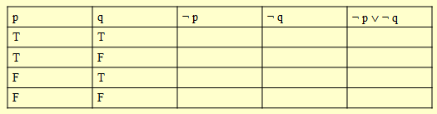
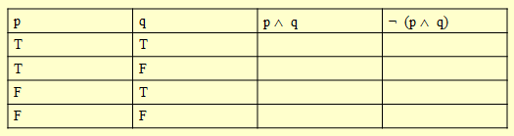
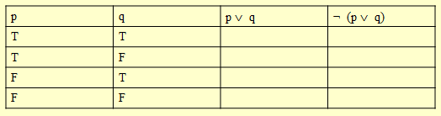
Part Three
Let
h = John is healthy
w = John is wealthy
s = John is wise

Write compound propositions representing
- John is healthy and wealthy but not wise
- John is not wealthy but he is healthy and wise
- John is neither healthy, wealthy, nor wise
- John is neither wealthy nor wise, but he is healthy.
- John is wealthy, but he is not both healthy and wise.
Part Four
Complete the following truth tables
