Section 4.5
Activity 1
Look at the following code. What does it do?
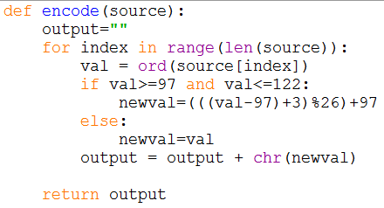 | 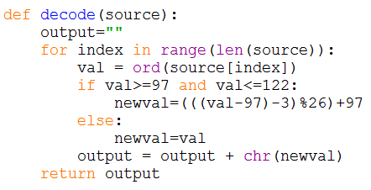
Activity 2
Let
A = {a, b, c}
B = {1, 2, 3}
d is defined as {(a,b), (b,c), (c,a)}
e is defined as {(a,3), (b,2), (c,1)}

- Draw an arrow diagram for each of these functions.
- What is e ◦ d
- What is d ◦ e

Activity 3
Let
- f: R→R and g: R→R
- f(x) = 2x + 3 g(x) = 3x + 2

- What is f ◦ g (2)
- f ◦ g (-3)
- f ◦ g (x)?
- g◦f (x)?

