Activity 1
- Student ID numbers at UNI are six consecutive digits.
  - How many total ID numbers are possible?
  - How many of those consist of all the same digit?
  - How many of those consist of exactly five consecutive “same” digits (such as 122222)?
Activity 2
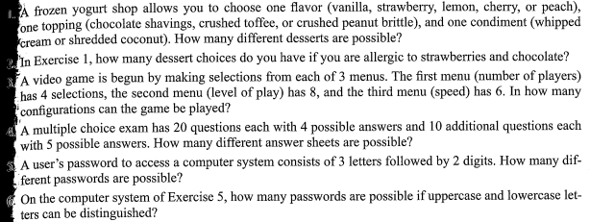
Activity 3
Calculate the value of:
- P(7,3)
- P(10,5)
- P(6,5)
- P(6,6)
- P(n,3)
- P(n,n-3)

Activity 4
We are going to elect a “student council” from the members of today’s class.
- In how many ways can we pick a President, Vice President, and Secretary?

- In how many ways can we do this PLUS pick a Treasurer and “Sergeant at Arms?

