Section 1.2 and 1.3
Part One
- Let
  - m = Juan is a math major
  - c = Juan is a computer science major
- How would we write
  - Juan is a math major but not a computer science major

  - Juan is either a math major or a computer science major

- Let
  - s = stocks are increasing
  - i = interest rates are steady
- How would we write
  - Stocks are declining while interest rates are steady

  - Neither are stocks increasing nor are interest rates steady

Part Two
Let
h = John is healthy
w = John is wealthy
s = John is wise

Write compound propositions representing
- John is healthy and wealthy but not wise
- John is not wealthy but he is healthy and wise
- John is neither healthy, wealthy, nor wise
- John is neither wealthy nor wise, but he is healthy.
- John is wealthy, but he is not both healthy and wise.
Part Three - Complete the following truth tables
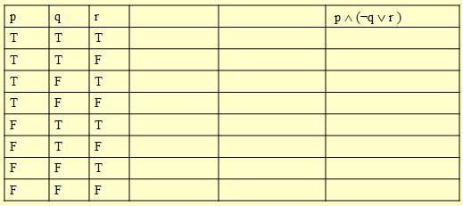
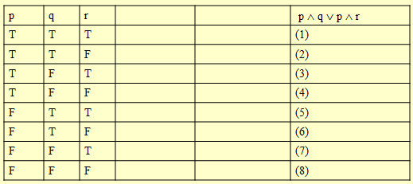
Part Four - For each of the following sentences identify which part is p and which part is q such that they are in the implication form p → q.
- If you study in this course you will get an A.
- Tomorrow is Friday if today is Thanksgiving.
- n is prime implies n is odd or n is 2.
- Tim is Ann’s father is sufficient for Jim being her uncle and Sue being her aunt.
- n is divisible by 6 only if n is divisible by 2 and n is divisible by 3.
- P being a rectangle is necessary for P being a square.

Part Five
Complete the following truth table.
