Section 1.3
Part One
For each of the following sentences identify which part is p and which part is q such that they are in the implication form p → q.
- If you study in this course you will get an A.
- Tomorrow is Friday if today is Thanksgiving.
- n is prime implies n is odd or n is 2.
- Tim is Ann’s father is sufficient for Jim being her uncle and Sue being her aunt.
- n is divisible by 6 only if n is divisible by 2 and n is divisible by 3.
- P being a rectangle is necessary for P being a square.

Part Two
Complete the following truth table.
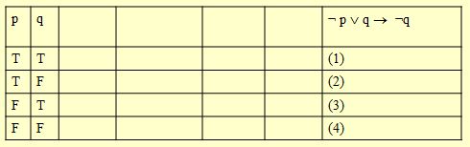

Part Three
For the following statement:
- If my client is guilty, then the knife was in the drawer

Write the following
- Converse

- Contrapositive

- Inverse

- Negation

