Section 1.3 and 1.4
Part One - Identify the hypothesis/antecedent in each of the following implication statements.
- If you study in this course you will get an A.
- Tomorrow is Friday if today is Thanksgiving.
- n is prime implies n is odd or n is 2.
- Tim is Ann’s father is sufficient for Jim being her uncle and Sue being her aunt.
- n is divisible by 6 only if n is divisible by 2 and n is divisible by 3.
- P being a rectangle is necessary for P being a square.
Part Two - Complete the following truth table.
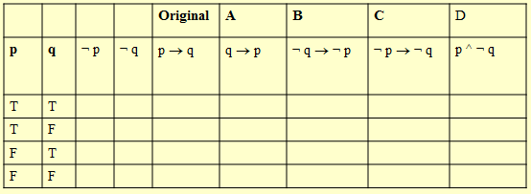

Part Three – “If my client is guilty, then the knife was in the drawer.”
Write the following “variations” for the implication written above
- Converse

- Contrapositive

- Inverse

- Negation

Part Four
Define these three terms
- Tautology

- Contradiction

- Logically Equivalent

