Section 4.1
Activity 1
Define the following terms:
- Function

- Domain

- Target

- Range

Activity 2
Let f: X → Y as shown by :  - What is the domain of f?  - What is the target of f?  - What is the range of f?  - What is f(a)? f(b)? f(c)? | 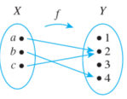

Activity 3
Which of the following are functions?
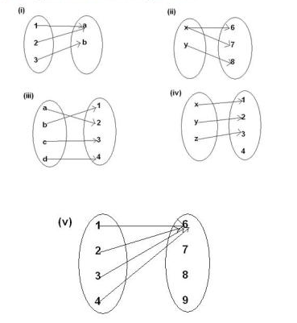
What if the same arrows went the other direction?

Activity 4
Which of the following are functions?
- f(x) = the town person x was born in
- f(x) = the schools person x went to
- f(x) = the college that person x graduated from
- f(x) = x + 5
- f(x) = 3 if x>2 otherwise f(x) = -2
- f(x) = 7 if x>0 or f(x) = -7 if x<0 or f(x) = 7 or -7 if x = 0

Activity 5
Represent f as a set of ordered pairs.

Activity 6
Consider:
L = {1,2,3,4,5}
R = {A,B,C,D,F}

Which of the following are functions from L to R?
- {(1,A),(2,B),(3,C),(4,D),(5,F)}
- {(2,A),(2,B),(3,C),(4,D),(5,F)}
- {(1,A),(2,A),(3,B),(4,B),(5,B)}
- {(1,5),(2,4),(3,3),(4,2),(5,1)}
- {(2,A),(3,B),(4,B),(5,B)}

Activity 7
- Find all of the functions from X = {a,b} to Y={u,v}

- Find all of the functions from X = {a,b} to Y={u}

- How many functions would exist from X = {a,b,c,d} to Y={u,v,x}

