Section 4.4
Activity 1
Give me an example of a relation that is:
- A bijective function.
- An injective (one-to-one) function only.
- A surjective (onto) function only.
- A function, but neither 1-to-1 or onto.
- Not a function.

Activity 2
- What is the image of Adams?  - What is the image of Epp?  - What is the inverse image of B?  - What is the inverse image of A? | 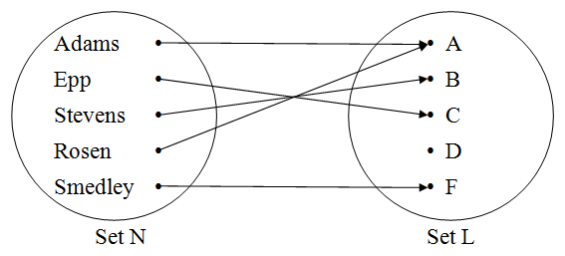

Activity 3
Find the inverse of each of these functions.
- f: X → Y as shown by arrow diagram to the left  - g: R→R g(x) = 2x + 3  - h: R→R h(x) = x² + 4 | 