Chapter 7 wrapup, Section 8.1
Activity 1 – For each of the following, what is f()?
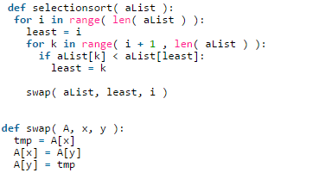
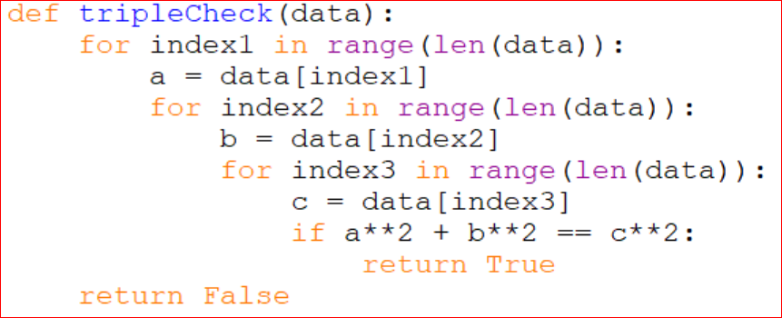

Activity 2
For each of the previous what is the algorithm’s Big-Oh, Theta, and Omega?

Activity 3
- Sequence

- Arithmetic Sequence

- Geometric Sequence

- Increasing Sequence

- Decreasing Sequence

- Non-Increasing/Non-Decreasing Sequence

- Common Difference

- Common Ratio

- Factor

Activity 4
Write the first six terms of each of the following sequences:
- Arithmetic, I₀ = 3, Factor = 2
- Geometric, I₀ = 3, Factor = 2
- Arithmetic, I₀ = 4, Factor = -1.5
- Geometric, I₀ = 2, Factor = - 2

