Sections 8.2 and 8.3
Activity 1
Write the first six terms of each of the following sequences:
- I₀ = 2, I_{k} = I_{k-1} – 2 for k>0
- I₀ = 5, I_{k} = 3*I_{k-1} for k>0
- I₀ = 1, I_{k} = 2*I_{k-1} + 1 for k>0
- I₀ = 1, I_{k} = k*I_{k-1} for k>0

Activity 2
- A colony of bats is counted every 2 months.
- The first four counts are 1200, 1800, 2700, 4050.
- Assuming this growth rate continues, write a recurrence relation for this data.

- What will the 10th count be?

Activity 3
Write the first seven terms of each of the following sequences:
I₀ = 5, I₁ = 11,
I_{k} = 5I_{k-1} – 6I_{k-2} for k>1

I₀ = 4, I₁ = -2,
I_{k} = - I_{k-1} + 2I_{k-2} for k>1

Activity 4
Evaluate the summations expressed below
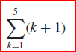
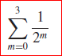
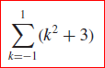
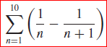

Activity 5
Rewrite each of the following separating off the final term.
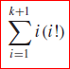
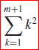
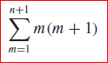

Activity 6
Write each of the following in summation notation.
